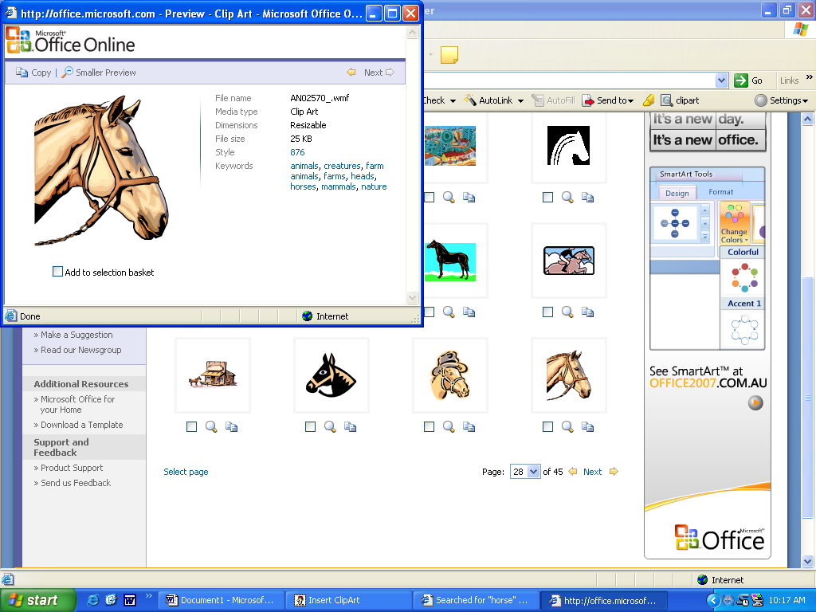

B . A . D

BALLAN & DISTRICT

ADULT RIDING CLUB

|  |  |  |  |  |  |  |  |  |  |  |  |  |  |
| --- | --- | --- | --- | --- | --- | --- | --- | --- | --- | --- | --- | --- | --- |
| BALLAN & DISTRICT ADULT RIDING CLUB  Pres Lesley 0400 014 967  Sec Judith 0408 791 097  Tres Josie 0418 508 723 **POST OFFICE BOX 108, BALLAN 3342**  **MEMBERSHIP FORM**  **Nov 2023-Oct 2024** | | | | | | | | | | | | | |
| NAME |  | | | | ADDRESS | | | |  | | | | |
| SUBURB | P.CODE | | | | | MOBILE | | |  | | HOME PH | |  |
| EMAIL |  | | | | | | | | | | | | |
| WORKING WITH CHILDREN CHECK NUMBER & exp date:____________  EMERGENCY CONTACT NAMES & NUMBERS | | | | | |  | | | | | | | |
|  | | | | | | | |
| HORSE NAMES | |  | | | | | | | | | | | |
| I hereby give permission for a vet to be contacted if it is deemed necessary in my absence, for the provision of emergency medical care for my horse, this will be at my own expense and I will not hold Ballan Adult Riding Club or its members responsible in anyway. | | | | | | | | | | | | | |
| SIGNED | |  | | | | | | | | Date |  | | |
| CAR REGO | |  | | FLOAT REGO | | |  | | | HRCAV member number | |  | |
| **MEDICAL INFORMATION** | | | | | | | | | | | | | |
|  | | |  | | | | |  | | |  | | |
| LAST TETNUS INJECTION | | |  | | | | | MEDICARE # | | |  | | |
| AMBULANCE COVER | | | Y / N | | | | | AMBULANCE MEMBER # | | |  | | |
| ALLERGIES | | |  | | | | | | | | | | |
| PRIVATE HEALTH INSURANCE | | | Y / N | | | | | MEMBERSHIP # | | |  | | |
| Please tick if you consent to your contact details being added to a club directory 🞏 | | | | | | | | | | | | | |
| Chaff Chat to be emailed out to every member via HRCAV | | | | | | | | | | | | | |
| Please tick membership option (HRCAV insurance $170)    🞏 SATURDAY RALLY Membership - $200 + (HRCAV)= **$370.00** allows attendance at 5 club rallies and there on $40 per rally. Additional venue hire to be charged if using indoor facilities  🞏 WORKING EQUITATION Membership- $50 + (HRCAV)= **$220.00** plus $35 and venue hire at each clinic  🞏 COMPETITION Membership - $50 + (HRCAV) = **$220.00** Members may compete as BADAC  Note Members who are already financial with HRCAV through another club are not required to pay the $170.00 HRCAV insurance component in the above fee structures.  I _______________________________, hereby apply for membership of the Ballan & District Adult Riding Club for an annual fee as indicated above and agree to abide by the rules and regulations as set down by the Horse Riding Club Association of Victoria (HRCAV) and the Ballan & District Adult Riding Club.  Please make your cheque payable to Ballan & District Adult Riders Club, P.O Box 108, BALLAN ,3342.  Or direct debit to Bendigo Bank bsb 633 000 acc 161344171 with a membership name reference THANK YOU. | | | | | | | | | | | | | |
| Signed: | |  | | | | | | | | Date |  | | |